Task 01 : What kind of collision resolution strategy is implemented in the below Hash Table ?
import java.util.*;

class Task01 {

LinkedList<Entry>[] data = new LinkedList[10];

public void put(String keyval, int value) {
int index = Math.abs(keyval.hashCode() % data.length);

if (data[index] == null) {
data[index] = new LinkedList<>();
}
for (Entry e : data[index]) {
if (e.keyval.equals(keyval)) {
e.value = value;
return;
}
}

data[index].add(new Entry(keyval, value));
}

static class Entry {
String keyval;
int value;

Entry(String k, int v) {
keyval = k;
value = v;
}
}
}

Is it using:
1)to fill collisions is it linear probing with backtracking
or
2)Opening address by placing values at next available bucket
or
3)at each index chaining using a linked list
or
4)on each collision resizing hash table.

Solution :
The hash table implementation uses:
3) At each index chaining using a linked list
Explanation: When a collision occurs (i.e., two keys hash to the same index), the code stores all entries at that index in a LinkedList. This is called "separate chaining" or "chaining using a linked list".
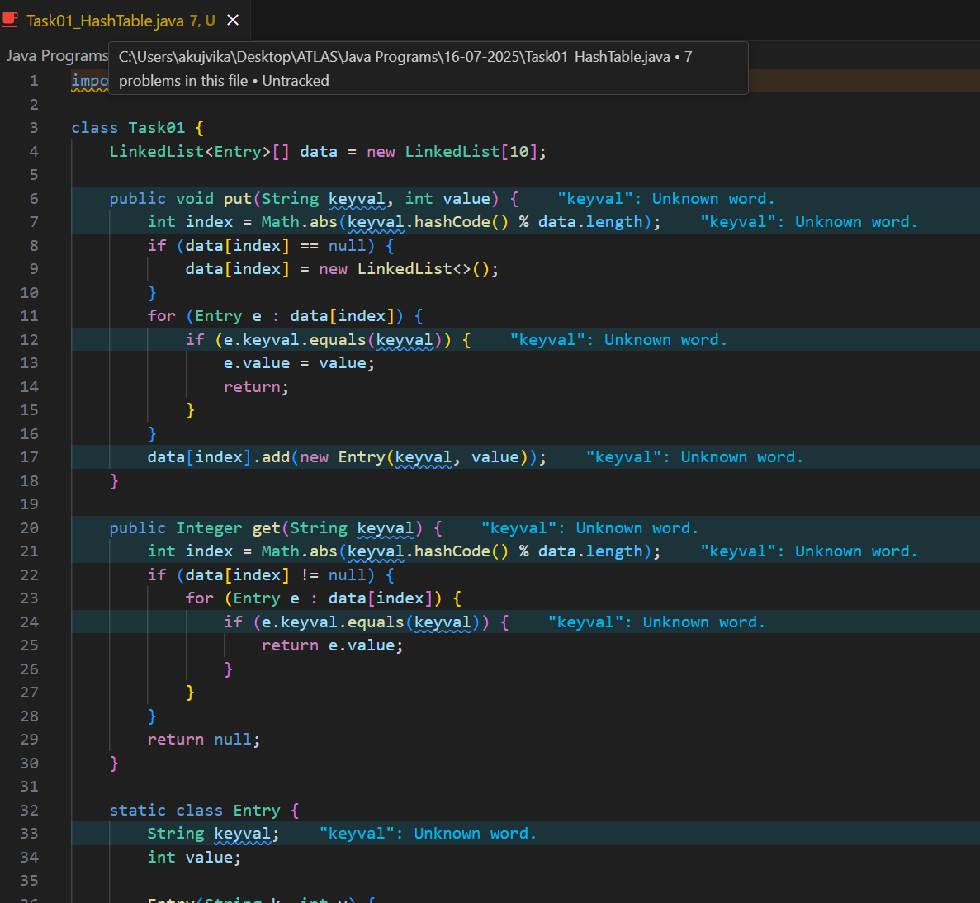
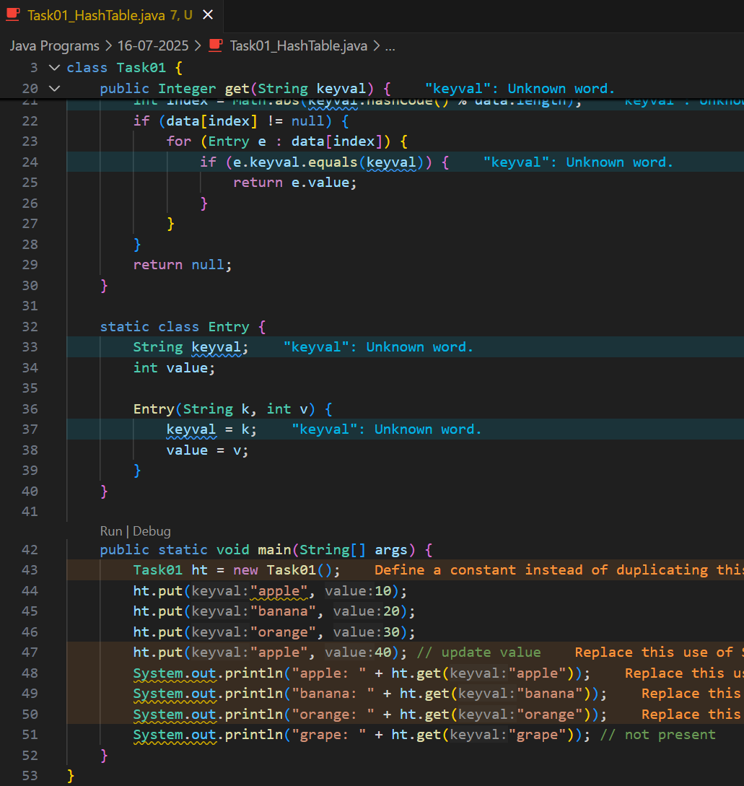
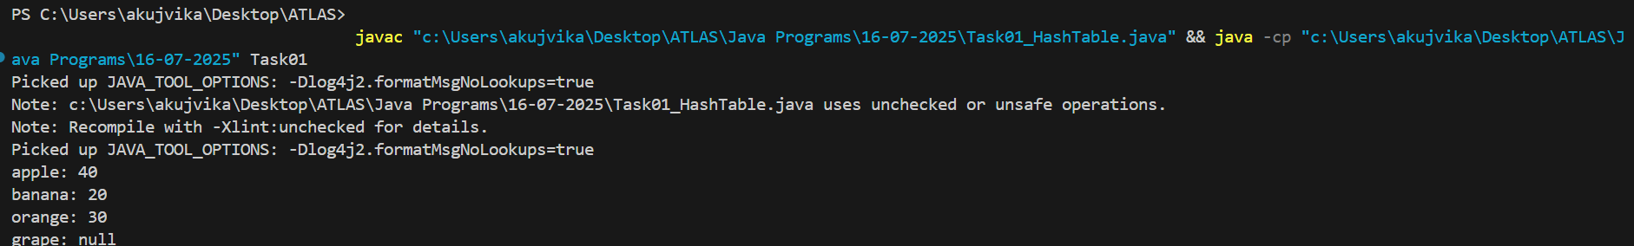

Task 02: Wap to take input from the user a 5 digit no and display digit by digit in the output.

Hint:
If input is 456897
Output:
units digit is 7
Ones digit is 9
Hundreds digit is 8
Thousands digit is 6
10 thousands digit is 5
Lakhs digit is 4
Solution : 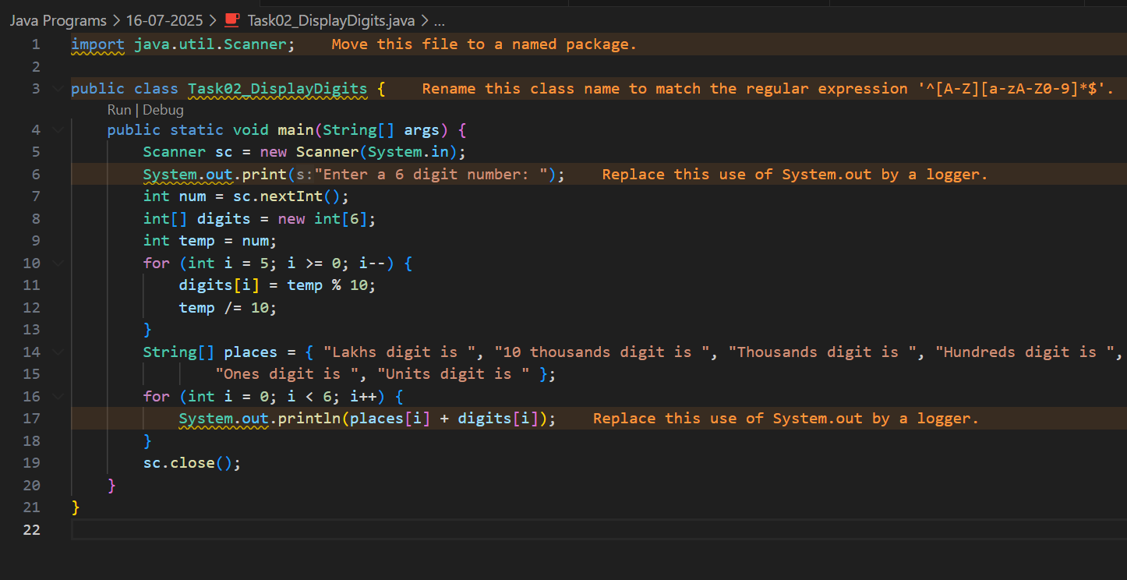
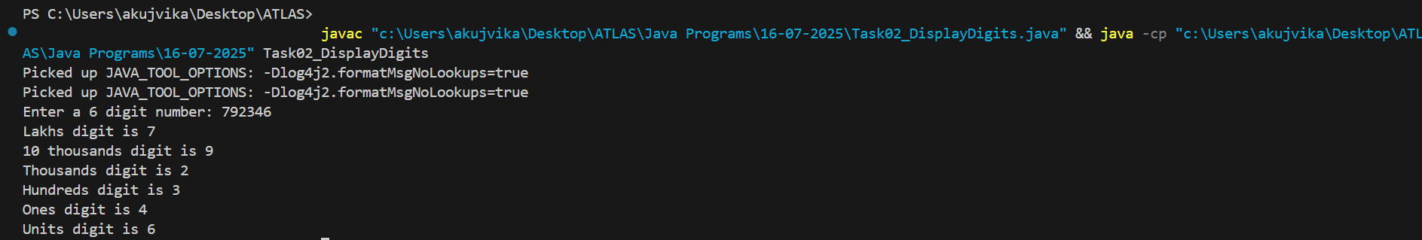

Task 03: Wap to take number from the user and display the no of digit it has
Hint: If input is: 10,000 & Output: Its a 5 digit number
Solution :
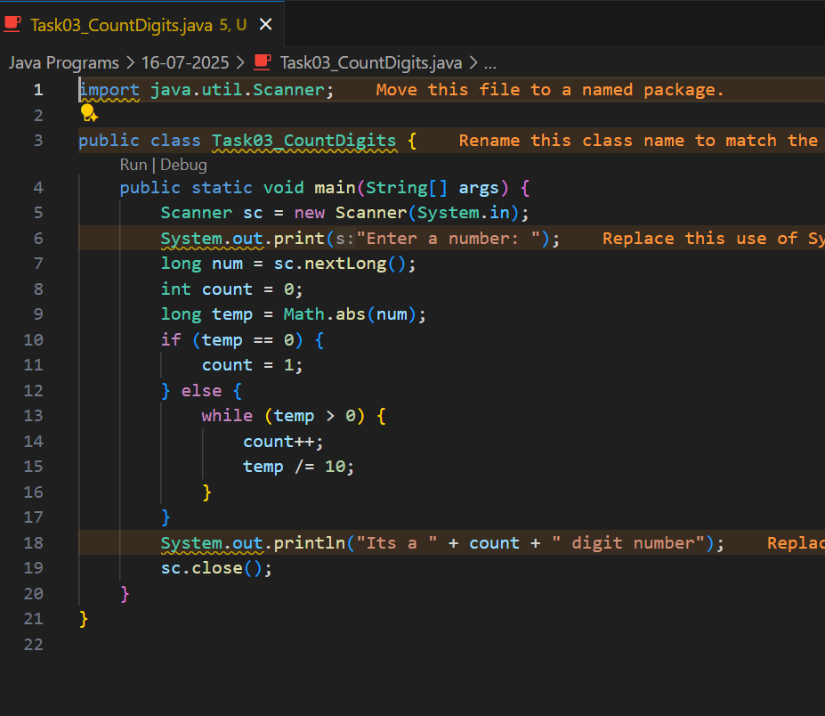
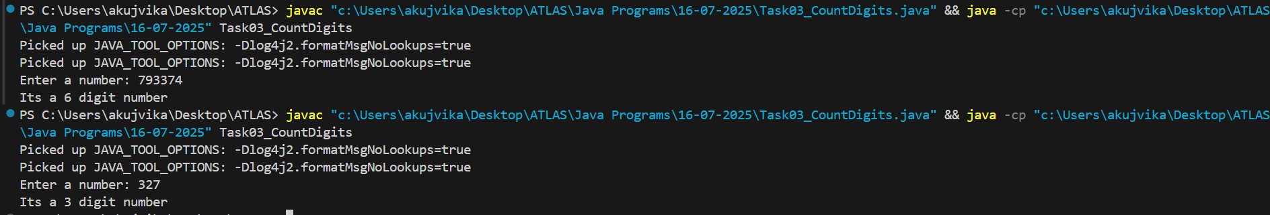

Task 04: Wap to display the groups of digits depending upon the unit digits
Hint:
If input is 45,81, 85,100,20. 95,60,10,21
Output:
Array 1 has : 100,20,60,10
Array 2 has : 81, 21
Array 3 has : 45 , 85 ,95
Solution :
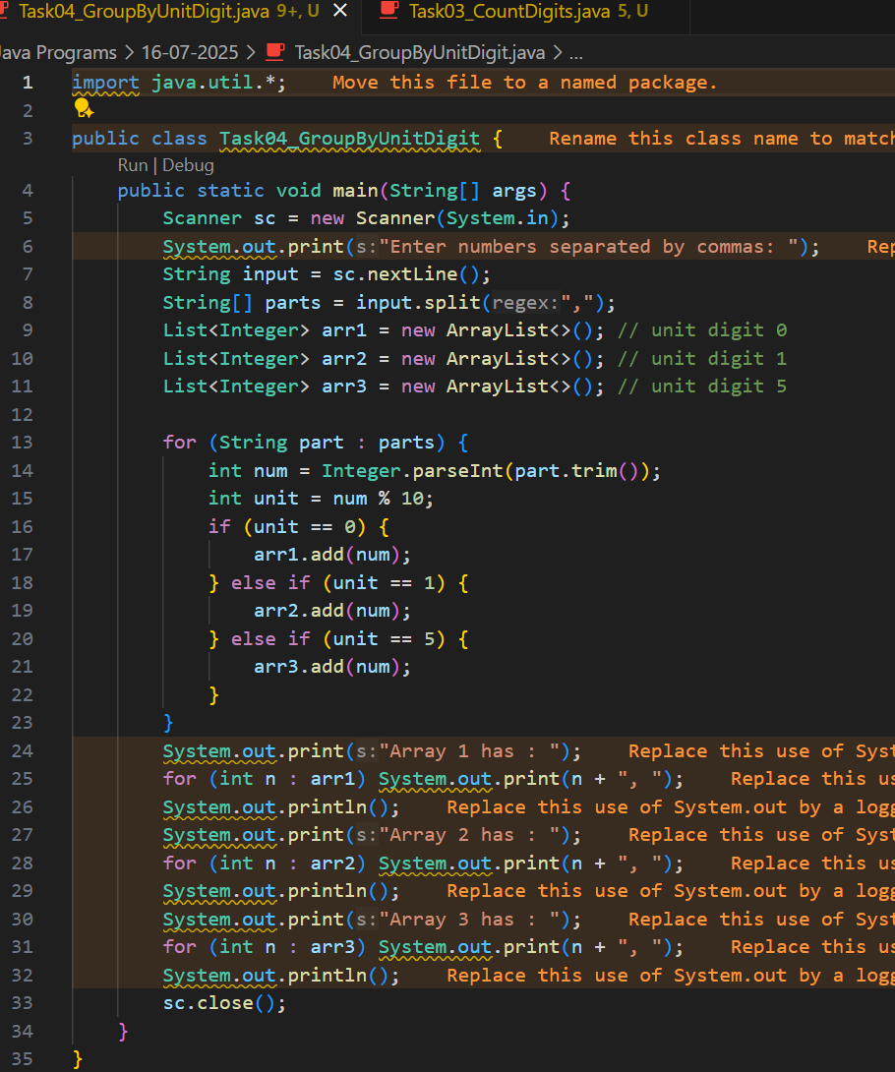
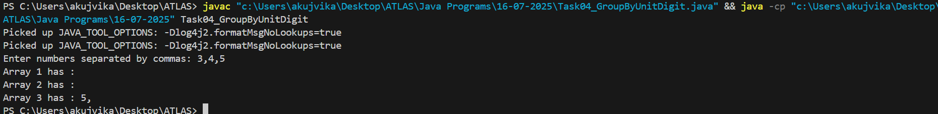

Task 5: Algorithm for radix sort
Solution:
1. Find the maximum number in the array to determine the number of digits.
2. Do the following for each digit (starting from the least significant digit to the most significant digit):
a. Use a stable counting sort to sort the array according to the current digit.
3. Repeat the process for each digit position.
4. The array will be sorted after processing all digit positions.

Task 6: Pseudo code for radix sort
Solution:
RADIX-SORT(A)
1. d = number of digits in the largest number in A
2. for i = 1 to d do
3. use a stable sort (like counting sort) to sort array A on digit i
4. end for

COUNTING-SORT(A, digit)
1. Initialize count array C[0..9] to 0
2. For each element in A, extract the digit at 'digit' place and increment C[digit]
3. Modify C so that each C[i] contains the actual position of this digit in output array
4. Build the output array using C and the digit
5. Copy the output array to A

Task 7 : WAP for radix sort.
Solution :
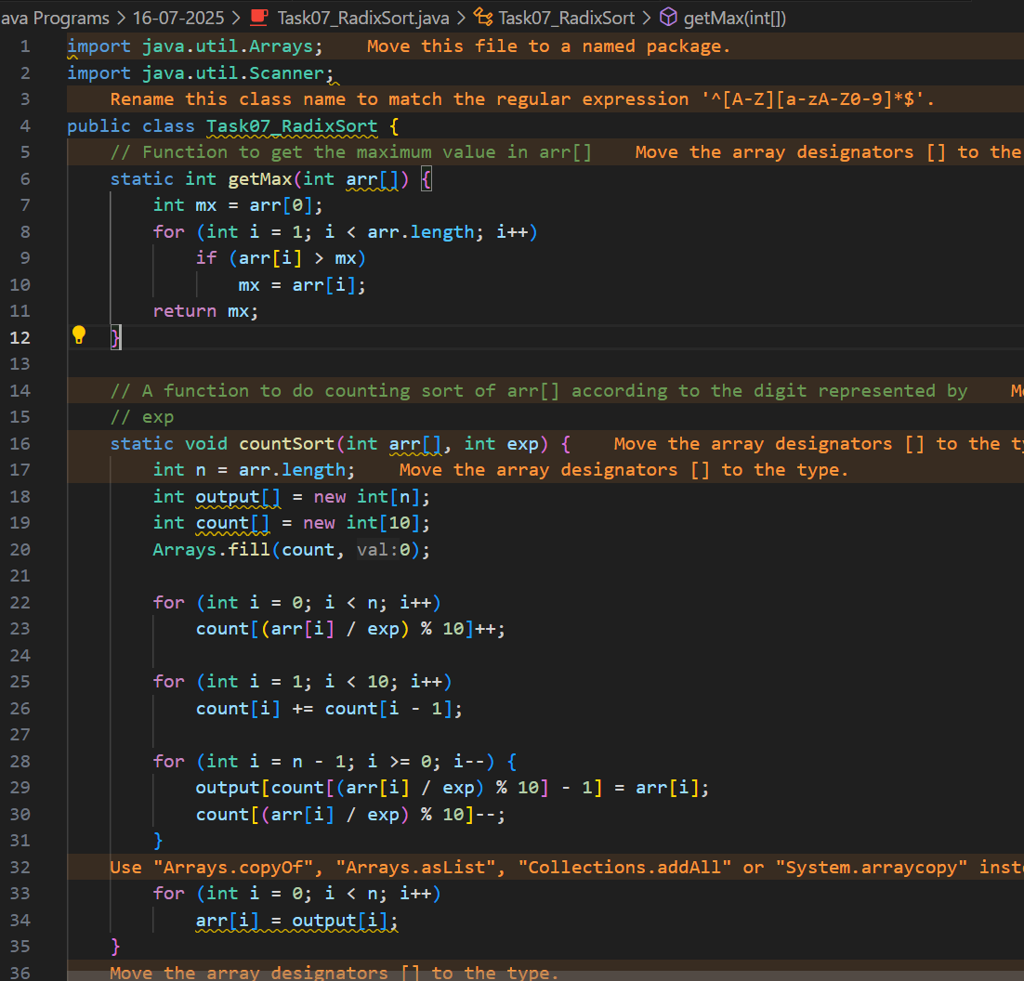
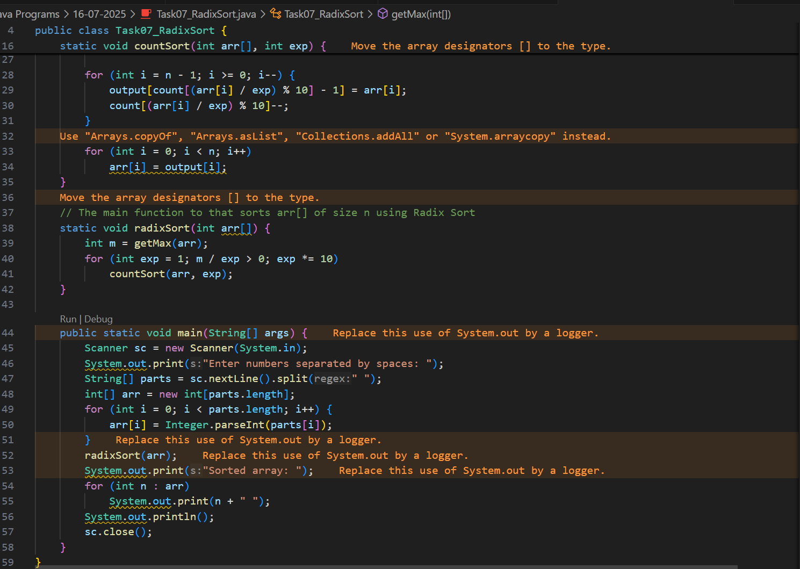
Task 08: Do you find any significance change between the breadthFirstSearchRecursive() approach compared to the standard BFS?

a)Will it the need for queues entirely by using a stack-based recursion?

b)Will it simplifies implementation by using queues implicitly within recursive function calls?

c)will it achieve same result but emphasizes on recursive style using the same level-order logic with explicit queue management?

d)will it processes nodes in post-order sequence to avoid memory allocation?

Solution : The correct option is that it achieves the same result but emphasizes a recursive style using the same level-order logic with explicit queue management.

Explanation : Yes, a recursive BFS achieves the same result as standard BFS but emphasizes a recursive style. However, it still uses explicit queue management to maintain the correct level-order logic.

Task 09: What is memorization? Explain it & provide examples.
Solution: Memorization is an optimization technique used to speed up programs by storing the results of expensive function calls and returning the cached result when the same inputs occur again. It is commonly used in recursive algorithms to avoid redundant calculations.

Explanation:
When a function is called, its result is saved (cached) based on its input parameters.
If the function is called again with the same parameters, the cached result is returned instead of recalculating it.
This is especially useful in problems with overlapping subproblems, such as Fibonacci numbers, dynamic programming, etc.

Example in Java (Fibonacci with memorization):
import java.util.HashMap;

public class Fibonacci {
static HashMap<Integer, Integer> memo = new HashMap<>();
public static int fib(int n) {
if (memo.containsKey(n)) return memo.get(n);
if (n <= 2) return 1;
int result = fib(n-1) + fib(n-2);
memo.put(n, result);
return result;
}
public static void main(String[] args) {
System.out.println(fib(10)); // Output: 55
}
}

Task 10: What do you understand by Dynamic Programming. Explain it & provide examples.
Solution : Dynamic Programming (DP) is a method for solving complex problems by breaking them down into simpler subproblems and solving each subproblem only once, storing their solutions (usually using a table or memoization). It is especially useful for optimization problems with overlapping subproblems and optimal substructure.

Key points:
Overlapping subproblems: The problem can be broken into subproblems which are reused multiple times.
Optimal substructure: The optimal solution to the problem can be constructed from optimal solutions of its subproblems.
DP avoids redundant calculations by storing results of subproblems.

Example 2: 0/1 Knapsack Problem (Java) :
public static int knapsack(int W, int[] wt, int[] val, int n) {
int[][] dp = new int[n+1][W+1];
for (int i = 0; i <= n; i++) {
for (int w = 0; w <= W; w++) {
if (i == 0 || w == 0)
dp[i][w] = 0;
else if (wt[i-1] <= w)
dp[i][w] = Math.max(val[i-1] + dp[i-1][w-wt[i-1]], dp[i-1][w]);
else
dp[i][w] = dp[i-1][w];
}
}
return dp[n][W];
}
}
Task 11: Can you write Fibonacci series using dynamic programming?
Solution : 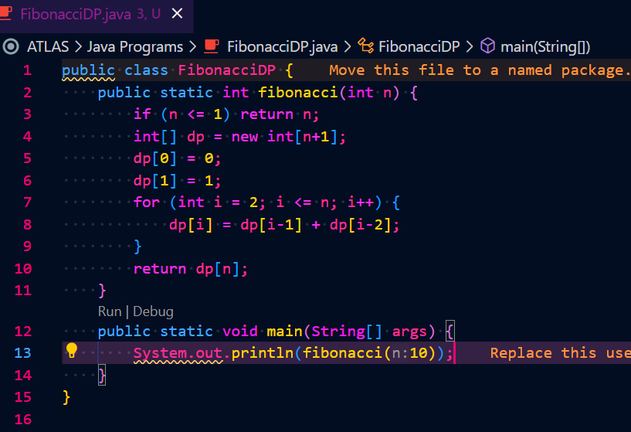

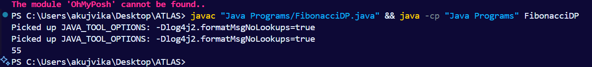

Task 12: How does heap sort work? explain the technique
Solution : Heap sort is a comparison-based sorting algorithm that uses a binary heap data structure. Here’s how it works:

Build a max heap from the input data. In a max heap, the largest element is at the root.
Swap the root (maximum value) with the last element of the heap.
Reduce the heap size by one and heapify the root to maintain the max heap property.
Repeat steps 2 and 3 until the heap size is 1.
The process ensures that the largest elements are moved to the end of the array one by one, resulting in a sorted array.

Key points:

Heap sort has O(n log n) time complexity.
It is not a stable sort.
It sorts in place (no extra memory needed).

